Music development plan summary:
East Leake Academy

Overview
Detail | Information
Academic year that this summary covers | 2024-2025
Date this summary was published | 25th July 2024
Date this summary will be reviewed | 25th July 2025
Name of the school music lead | Chloe Phillips
Name of school leadership team member with responsibility for music (if different) | Luke Tebbett
Name of local music hub | Nottinghamshire Music Hub
Name of other music education organisation(s) (if partnership in place) | MLC Academy

Part A: Curriculum music
This section covers the content of lessons and music qualifications that pupils can achieve. The East Leake Academy Website has an overview of the music curriculum, including the number of hours timetabled for each year group.
The curriculum at East Leake Academy is based on the National curriculum with elements from the Model Music Curriculum (March 2021) and the Ofsted Research Review Series (July 2021). The curriculum works towards developing listening, composition and performance skills through the gradual introduction of new ideas and concepts, whilst consistently repeating key curricular content across every topic.
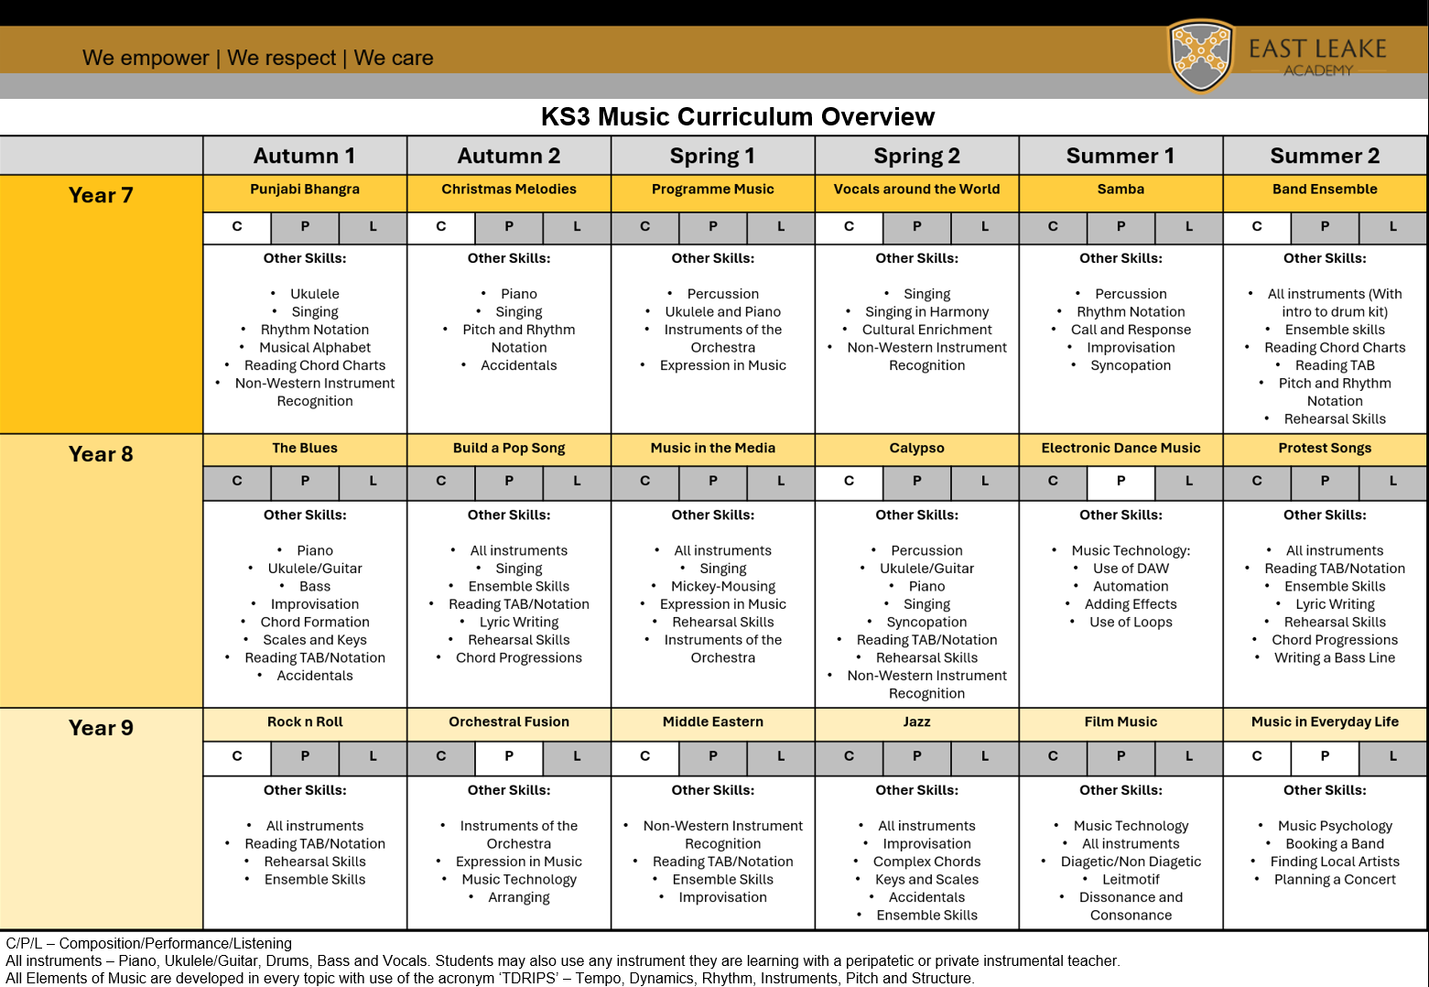
Curriculum Overview

Year 7
Punjabi Bhangra
Students revisit knowledge of the musical alphabet (from key stage 2) and use this to build ukulele skills in a whole class ensemble. Students will participate in whole class singing every lesson to facilitate their intrinsic understanding of pitch and rhythm. The musical elements acronym ‘TDRIPS’ is introduced and cemented. Students will learn the basics of reading chord charts, the four chord trick and rhythm notation. A range of songs are used to achieve this with a focus on Punjabi Bhangra towards the end of the half term for the assessment piece. Students develop cultural understanding.
Christmas Melodies
Students develop their notation and instrumental skills through the introduction of accidentals, the piano and pitch notation. Students work towards an individual or pair performance of a Christmas melody on the piano.
Programme Music
Students refine their piano and ukulele skills in this unit during a group composition activity. Students are also introduced to classroom percussion instruments. Students learn the families of instruments and the members of each family. Students learn how musical elements are used to represent an image or expression in music through listening and practical activities. Students develop an understanding of timbre through choosing instruments to suit their programme music composition.
Vocals Around the World
Students continue to refine their singing skills through the basics of vocal harmony, canon and smaller group singing. Students develop cultural understanding and cultural capital through an array of different vocal genres.
Samba
Students build on basic understanding of rhythms through syncopation, more in-depth rhythm notation and polyrhythms. Students learn to hold their own part within an ensemble. Students develop understand of structure through call and response and improvisation.
Band Ensemble
Students hone their instrumental and performance skills through small group performances of Riptide by Vance Joy. A basic drum beat and root notes on the bass guitar are introduced. Students learn the fundamentals of ensemble rehearsal.
Year 8
The Blues
Students develop their understanding of chord progressions (12 Bar Blues), bass lines and improvisation. They develop their holistic understanding of the origins of pop music. Students learn the basics of scales and key signatures and continue to refine their instrumental and notation skills.
Build a Pop Song
Students cultivate their creativity and artistic expression through creating a pop song from scratch. Students learn how to create chord progressions that fit a mood and continue to develop instrumental and ensemble rehearsal skills.
Music in the Media
Students continue to build on their instrumental and ensemble skills. Exploration of how music is used to convey mood, atmosphere and narrative in the media fosters creativity and critical thinking. Students revisit prior learning of the instruments of the orchestra.
Calypso
Students return to whole class ensemble style music making in this unit. Students develop independence in holding an individual part within an ensemble. Instrumental skills are refined while being adapted to a diverse range of musical genres.
Electronic Dance Music
Students learn the basics of using BandLab for Music Production. Students learn the musical features of EDM and how to recreate it using looping, automation, effects and sampling.
Protest Songs
Students continue to refine their instrumental, notation and ensemble skills in a group protest song composition. Students continue to explore how music can be utilised to convey emotion in addition to developing effective lyrics.
Year 9
Rock n Roll
Students build on prior instrumental learning but at greater depth with more technically challenging parts. Students learn key features of Rock N Roll including influences. Students continue to develop notation reading skills.
Orchestral Fusion
Students hone their auditory understanding of instruments of the orchestra. Students learn what fusion is and how different genres of music can be mixed. Students develop their BandLab skills through an arrangement of an Orchestral Fusion piece.
Middle Eastern
Students continue to develop their cultural understanding of a diverse array of musical genres. Students learn the importance of compositional features such as drones and develop understanding of non-western scales through practical activities.
Jazz
Students learn about the different genres within Jazz, including the historical and cultural context. Students deepen their understanding of chord formation and improvisation following a blues scale. Students continue to develop their ensemble and performance skills.
Film Music
Students hone their skills on BandLab by creating an original piece of film music to a brief. Students learn composition features such as leitmotif and diegetic sound. Students used a MIDI keyboard to record in sound and build confidence in their editing skills.
Music in Everyday Life
This is a 3 week unit before timetable promotion. Students who are taking music at KS4 are asked to prepare a performance for the start of their BTEC course. Students who have not chosen music learn how music can be used in everyday settings, such as music psychology and music therapy. Students learn how to continue to appreciate music in their lives through practical tasks such as booking a band for a party.
Year 10 and Year 11
At Key Stage 4 students currently undertake the Pearson BTEC Level 1/2 Tech Award in Music Practice. This is a vocational qualification which equips students with practical skills in music performance. This course is adaptable to the students’ strengths and needs, with opportunities to explore a diverse range of musical genres. Students develop their ability to perform, compose and use music technology as part of this course.
Special Educational Needs and Disabilities
East Leake Academy are committed to inclusion, with equity being essential to the curriculum. It is important that all students have access to the music curriculum with the opportunity to attain highly. It is recognised that some students will require scaffolding to attain these outcomes.
Music Qualifications
In addition to the offer of Pearson BTEC Level 1/2 Tech Award in Music Practice at Key Stage 4, all students can undertake graded music examinations with peripatetic teachers.

Part B: Co-curricular music
This section covers the opportunities for pupils at East Leake Academy to sing and play music, outside of lesson time, including choirs, ensembles and bands, and how pupils can make progress in music beyond the core curriculum.
Music Production, Instrumental and Vocal Groups and Clubs
East Leake Academy offers a range of extra-curricular activities that are offered free of charge and open to all students across all year groups. Rehearsals take place within the music department, or in the main hall in preparation for concerts and events.
- Whole School and Staff Choir
This is a singing group open to all students and staff. There are numerous performance opportunities throughout the year, including soloist opportunities. This is an inclusive group which provides students with a positive and collaborative experience. It fosters a safe environment for the development of vocal skills through the joy of music-making.
- Key Stage 3 Band
This ensemble is an opportunity for both students who have peripatetic or private lessons, and for students who have picked up classroom instrumental skills on instruments such as the piano and ukulele. It is an adaptable setting where students perform using a multitude of media, such as notation, tab, or chord charts. The ensemble performs a diverse repertoire with a focus on songs requested by members.
- Wind Band
East Leake Academy Wind Band is also open to all students and staff who play a wind instrument. There are differentiated parts for a range of playing abilities from grade 1 to grade 8. There is a focus on jazz repertoire.
- Solo Singers and KS4 Musicians
This is an opportunity for students to book out practise rooms to rehearse within their own chosen groups or solo. It fosters a sense of autonomy for older students at the school.

- Music Production and Song Writing Club
This club is hosted by an external provider. It offers students the opportunity to work with a professional musician on composition and production. There are opportunities to take work outside of school into recording studios.
Peripatetic Offer
East Leake Academy offers instrumental lessons on all instrument families delivered by specialist instrumental teachers. These are intended to support musical education through individualised instruction. Peripatetic lessons can be offered on an individual or small group basis.
Instrument Choices
- Piano: Offered through MLC
- Guitar: Acoustic, electric or bass guitar, offered through MLC
- Strings: Violin, viola and cello. Offered through Nottinghamshire Music Hub
- Woodwind: Flute, clarinet and saxophone. Offered through Jane Ingram, private teacher.
- Brass: Trumpet and trombone. Offered through Nottinghamshire Music Hub
- Percussion: Drum kit, offered through MLC.
- Voice: Offered through Alice Styles, private teacher.
Subsidised lessons for pupils on Pupil Premium and Instrument Hire can be offered through Nottinghamshire Music Hub.

Part C: Musical experiences
Instrument Demo Assemblies and Try Outs
Students in Key Stage 3 are encouraged to take up an instrument through demo assemblies with MLC and Nottinghamshire Music Hub. Following on from the demo session students have the opportunity to have a free ‘try out’ on an instrument of their choice.
Christmas Concert
East Leake Academy’s annual Christmas Concert offers students the opportunity to showcase their talents to a public audience. The event includes all instrumental and vocal groups as well as slots for solo performers. It is a highlight of the year for many and allows students to experience a sense of community and pride.
Performances to Local Primary Schools
Students are encouraged to take part in mini concerts to local primary schools at Christmas time. This helps build students confidence in performing but also seeds a love of music into local feeder schools, encouraging future participation.
ELA’s Got Talent
In the summer term students are encouraged to take part in the school talent show. This event features all music ensembles and solo performers. It also offers students a chance to see school staff perform, fostering an inclusive perception of music practise. Many students are also part of the audience, promoting a sense of pride of togetherness at the school.

In the future
